CANSAT SENSOR CALIBRATION

Go to \Resolve-Khi-main\Python Data Read - With Calibration and locate sensor_gui.py and gyro_gui.py . Accelerometer and Magnetometer calibration is performed in sensor_gui.py. Gyroscope calibration is performed in gyro_gui.py.

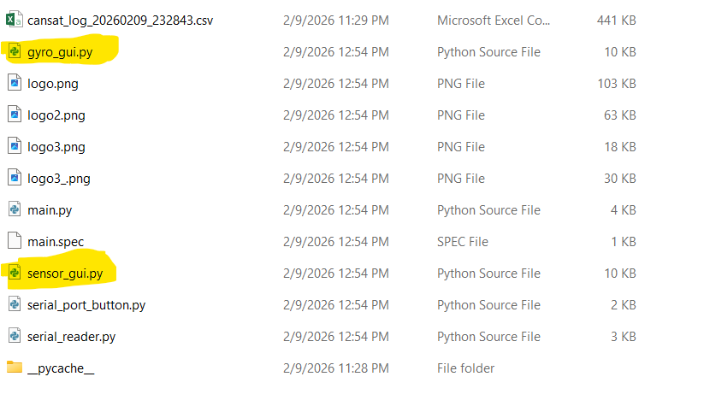
Figure 1: Source Files for Calibration

Accelerometer and Magnetometer Calibration
To calibrate the accelerometer and magnetometer separately, open sensor_gui.py and locate the code on lines 85–95 (Figure 2).
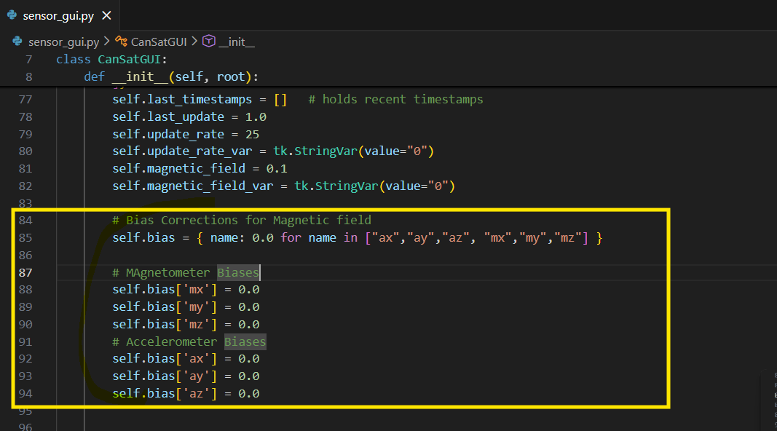
Figure 2: Accelerometer and Magnetometer Bias Correction Variables: sensor_gui.py

Lines 87–94 define the observed biases for the x, y, and z components of the magnetometer and accelerometer. These biases you insert here will be applied to the measurements in lines 200–206, and the corrected values will be shown in the dialog box.

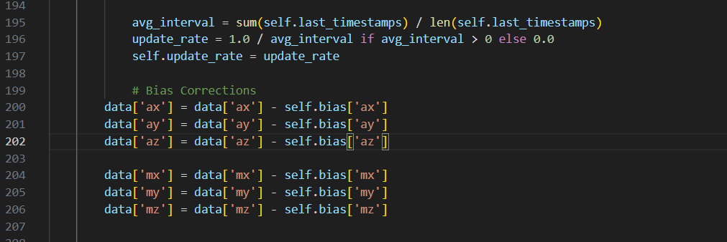
Figure 3: Excerpt of Code - Bias Correction

Bias Removal from Accelerometer
To remove accelerometer bias, use the gravitational constant g=9.8m/s2. Position the CanSat in upright and inverted orientations and record the corresponding az ​ measurements. The az ​ bias is calculated as the average of these values. Apply the same method to determine the biases for ax ​ and ay.
Insert the accelerometer bias values into lines 90–92 of the Python code. If the biases in lines 90–93 are correctly determined, the corrected values of ax, ay, az​ will remain within −9.8 to 9.8 over a wide range of CanSat motion.

Bias Removal from Magnetometer.
Just like Accelerometer, there is bias magnetometer measurements mx, my, mz.
The X and Y components (mx and my​) of the magnetometer are used to calculate the heading, which indicates the direction the CanSat is pointing relative to magnetic north.). See the Head filed in the 4th row and last column of Figure 4

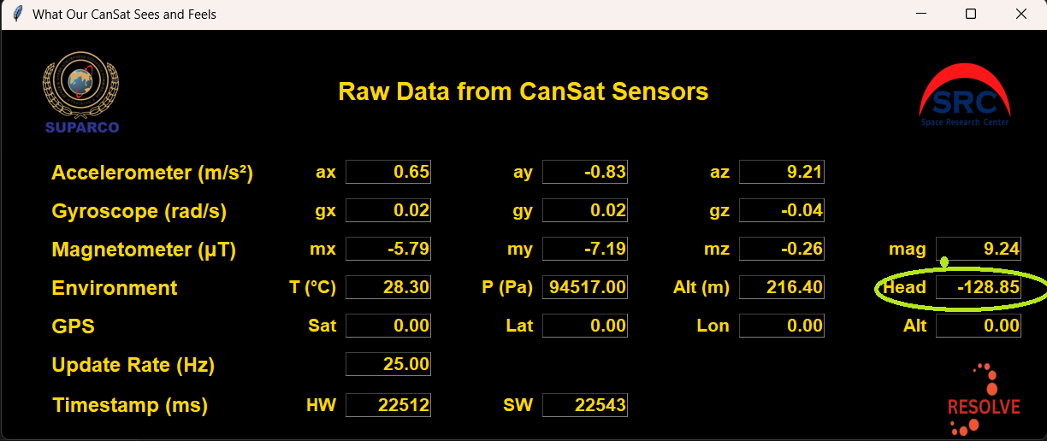
Figure 4:Magnetic Heading - Row 4, Last Column

Open sensor_gui.py and review lines 87–90 and 210–215 (Figure 4 and Figure 5 ) to see how the magnetic heading is calculated and displayed in the dialog box. The Python code computes the CanSat heading using the following formula:

$$Heading = 180+ \tan^{-1}\left(\frac{m_{y}}{m_{x}}\right)$$

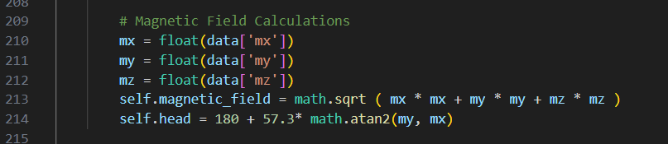
Figure 5: Heading Calculation in Python

How to check Bias in Magnetometer measurements:
Place the CanSat on a table or flat surface in an upright orientation, and rotate it through a full 360° circle. If there is no bias in the magnetometer measurements, the Head Field (4th row, last column in the dialog box) should also vary from 0° to 360° during the rotation. Observe the range of the Head Field and record it.
If the Head Field does not span 0° to 360° during a full rotation of the CanSat, it indicates that biases are present in the magnetometer measurements.

Calculate the biases in mx and my by observing their ranges (row 3 of Dialog box) during the 360 degree rotation of CanSat. Calculate the biases in mx values using the formulas (here min and max represent minimum and maximum values).

$$m_{x_{bias}}=\frac{\left(\max\left(m_{X}\right)+\min\left(m_{X}\right)\right)}{2}$$
$$m_{y_{bias}}=\frac{\max\left(m_{y}\right)+\min\left(m_{y}\right)}{2}$$

Figure 6: Magnetometer Biases Line 87-90
Calculate these Biases and save them into self.bias[‘mx’] and self.bias[‘my’] (Line 87-- of code, Figure 6).
Note down the range of Head Field upon 360 rotations of CanSat after this bias correction.

Gyroscope Calibration

Unlike Accelerometer and Magnetometer, the calibration of Gyroscope is performed automatically whenever python code runs.
- Open gyro_gui.py and check lines 65 to 72. Notice the variable self.calibrationSamples and flag variable self.performCalibration at line 70.

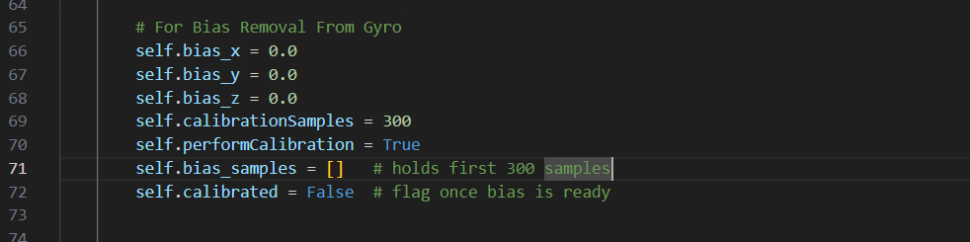
Figure 7: Gyroscope Bias Removal Variables and Flags
- Automatic calibration is performed in lines 170 -190. Observe that code.

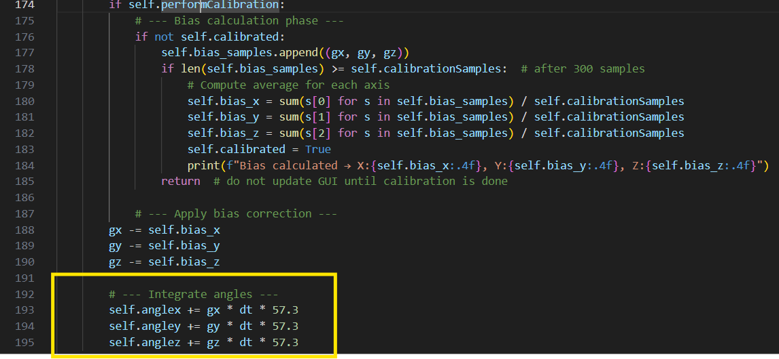
Figure 8: Gyroscope Calibrations

- Gyroscope rates are integrated in line 192-195.

- Go to line 70 and set self.performCalibration = False to disable automatic calibration. Observe the effects of small biases in the gyro rates on the calculated angles in angles dialog box. These angles are obtained by time-integrating the gyro rates.

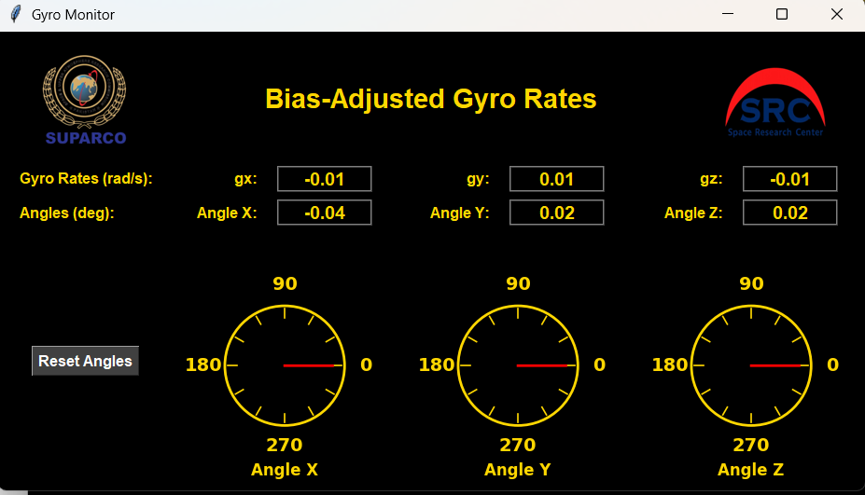
Figure 9:Gyroscope Dialog Box

